**Tutorial 28: Two-way Data Binding**

The easiest way to track what a user types into an input or select from a dropdown box is to use a v-model. The v-modal is a Vue directive which allows us to sync a form field with component in a way that gives us something known as two-way data binding. Two-way data binding refers to binding two ways between the template input and the component data so if the value updates in the input then the data property will update.

Make sure **Tutorial 27** is complete to be able to move on to this tutorial or clone the [vue3-firebase-course](https://github.com/younggrasshopperza/vue3-firebase-course) repository and go to branch called **Tutorial-27** and navigate to the web-form folder.

**Step 1:** In the **Signup.vue** file, create a data property that returns the data email with a value that has an empty string.

Look at the example below (**Between line 10 and 14**):

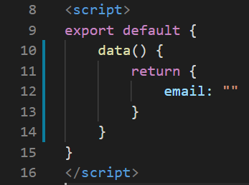

**Step 2:** In the **Signup.vue** file, we will be binding the email data value to the email input box. This value will automatically update as the user types into the input box with the value they type in.

In the input tag, include an attribute v-modal and make it equal to the email data property that we created which we will be using to track that input.

Look at the example below (**Line 4**):

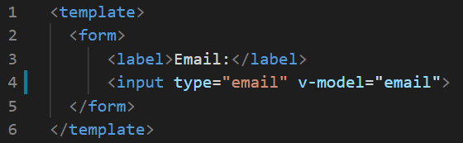

**Step 3:** In the **Signup.vue** file, we will create another input box where the user can type in their password.

Inside the form tag, create a label tag with the value “**Password:**” and an input tag with the type password and make it a required field. Include an attribute v-modal and make it equal password. Create the password data property with a value that has an empty string.

Look at the example below (**Between line 6 and 7, and line 16**):

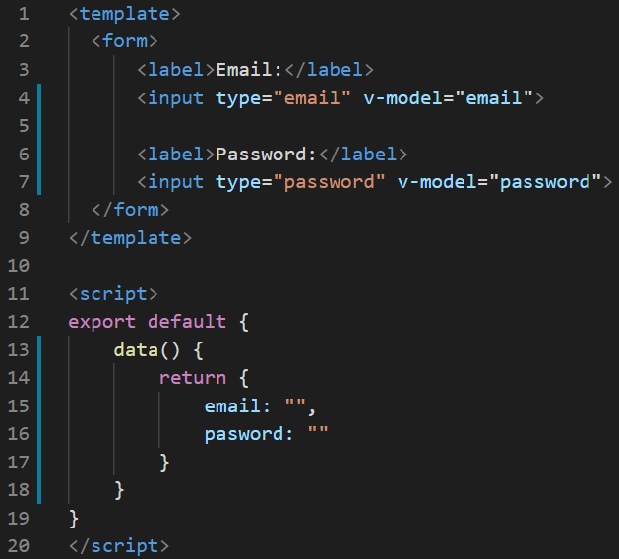

**Step 4:** In the **Signup.vue** file, we will output the email and password values that we are tracking so we can the values output in real-time.

Underneath the form tag, we will create 2 paragraph tags. The first paragraph tag will output the email input and the second paragraph tag will output the password.

Look at the example below (**Between line 10 and 11**):

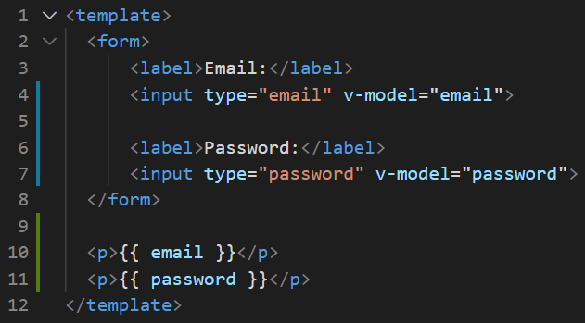

Type out anything you want and have a look at how we are tracking the inputs.

**Output:**

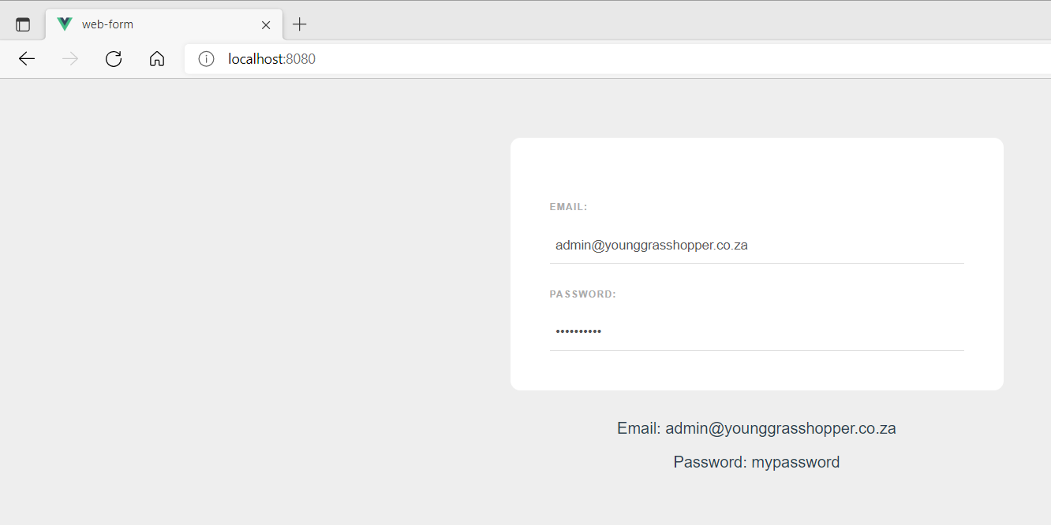

If we update the values from an empty string in the data property and provide them a value, we will see that value appear in the input. So that is what makes it a two-way data binding.

**Line 18 example:**

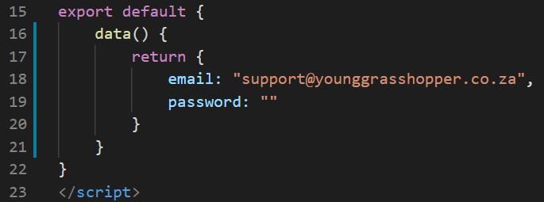

**Output:**

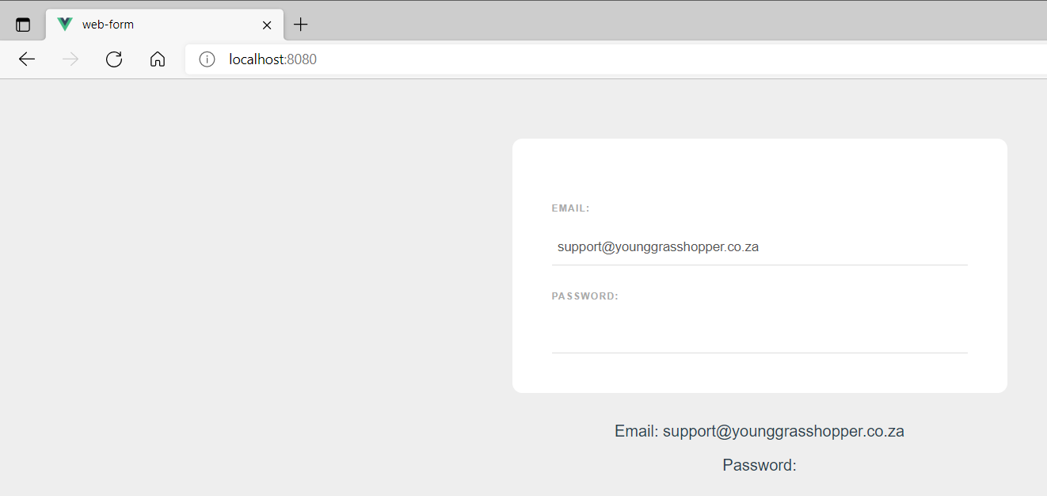

**You can view the code snippets from the** [**vue3-firebase-course**](https://github.com/younggrasshopperza/vue3-firebase-course) **repository under the Tutorial-28 branch**.